Exercise: Chapter 1

1. Account Created

2.

(i) Creating a directory and initializing git repository

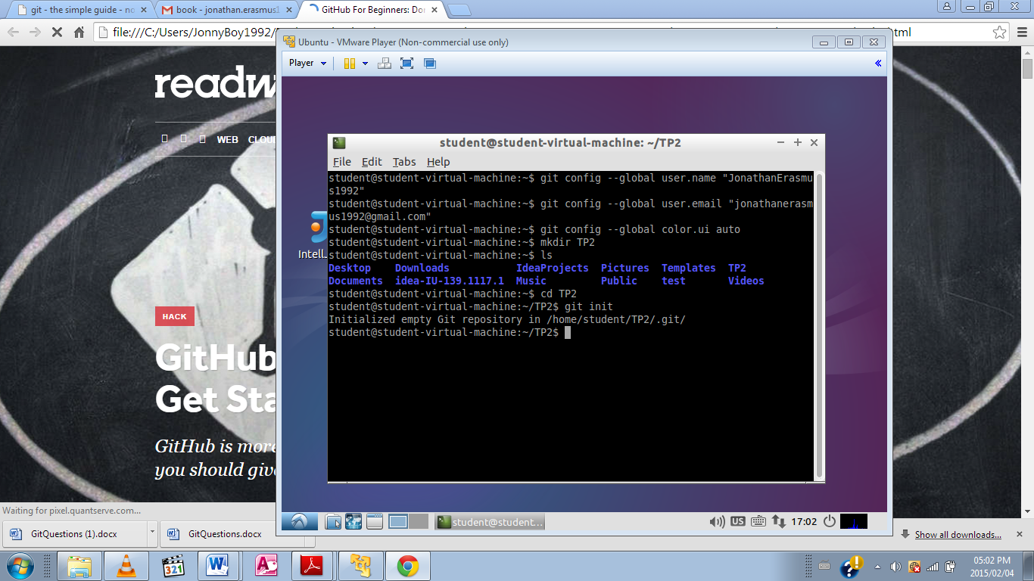

(ii) A new file has been added to the repository but is untracked not staged and thus showed in red text.

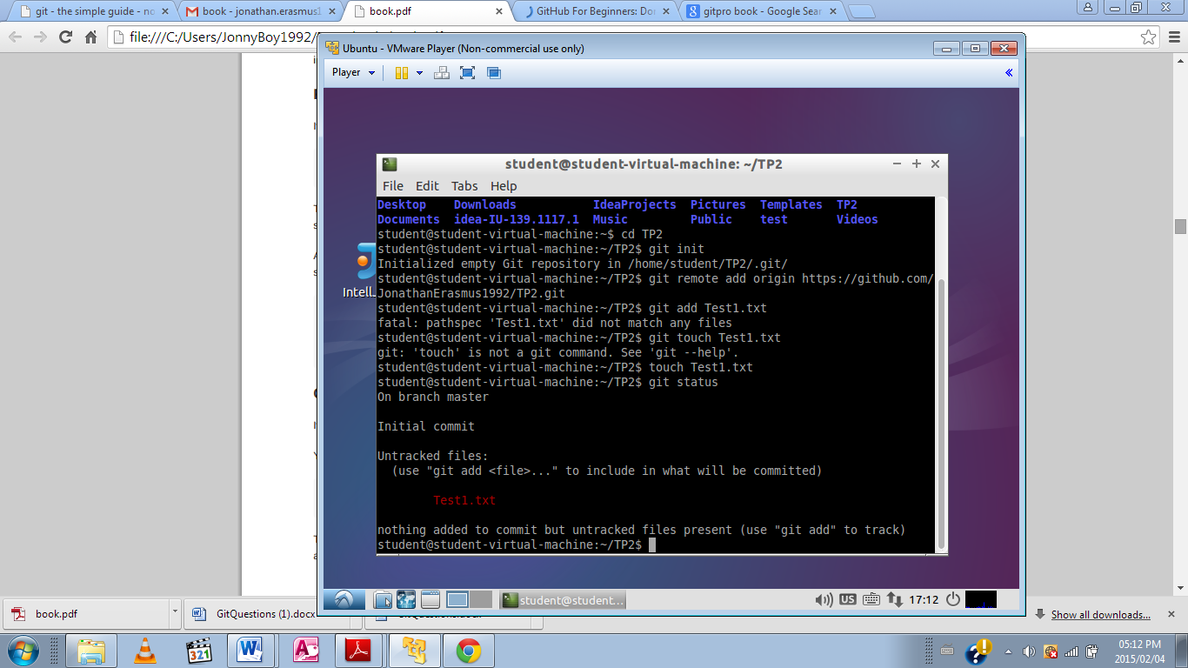

(iii) Added command to start tracking of newly created file.

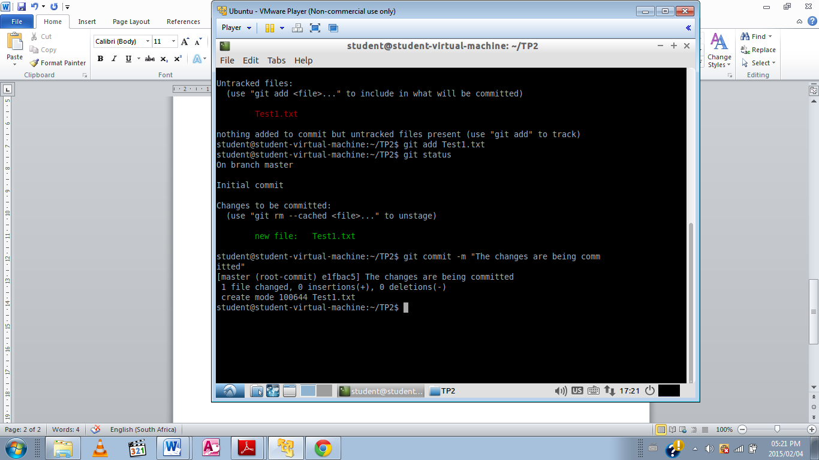

(iv) Added command to commit the file to repository



(v) They are newly created files, when a file is created it is untracked by default

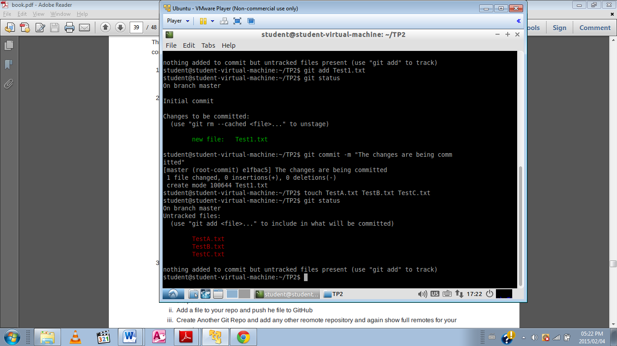

(vi) Opened and edited Test1.txt and then checked the status the modified file is indicated

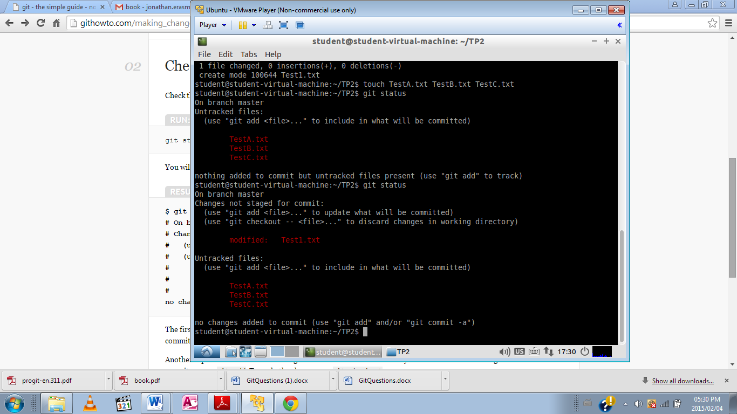

(vii) The files are shown as green tracked status and that they are ready to be committed

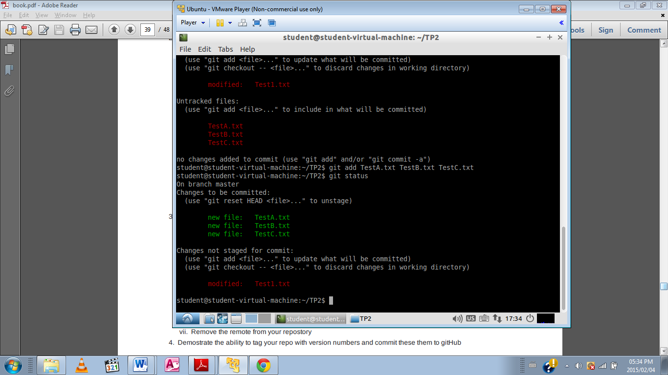

(viii) Added modified file to be tracked then committed.

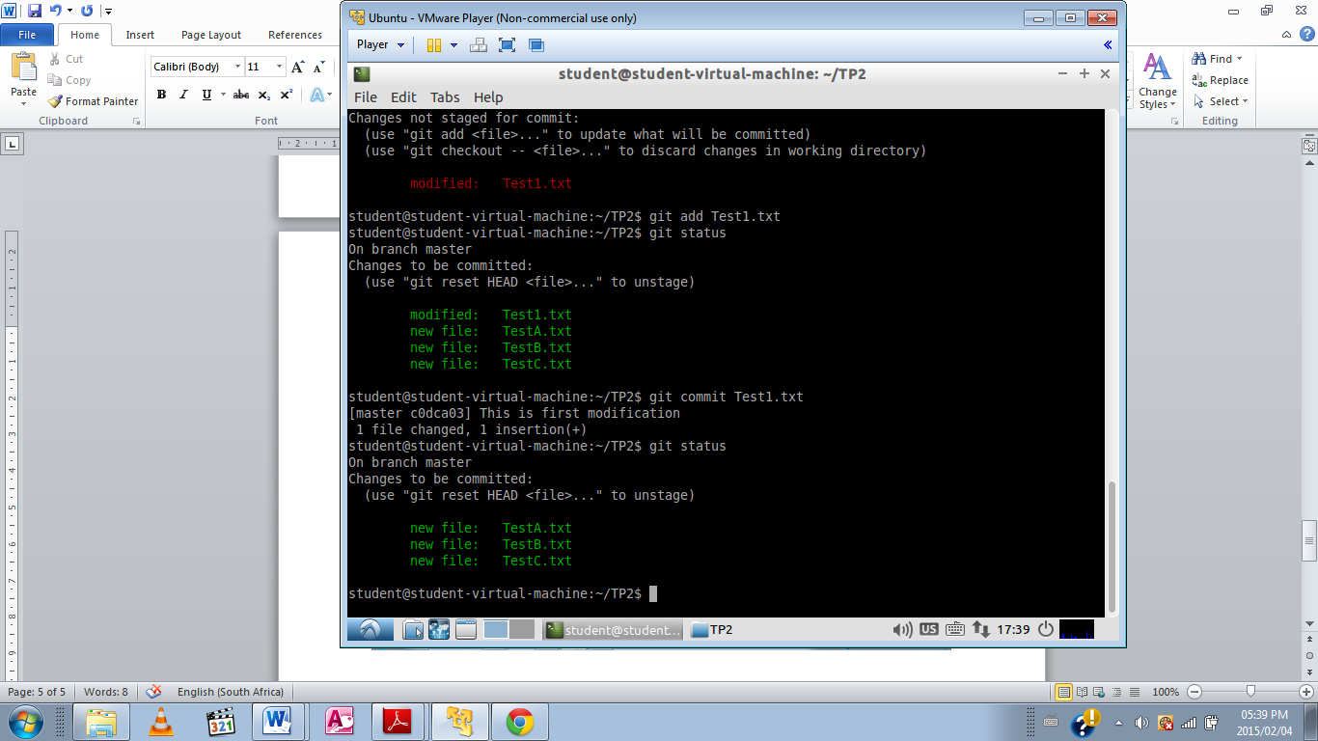

(ix) Entered command to view short status of files in repository

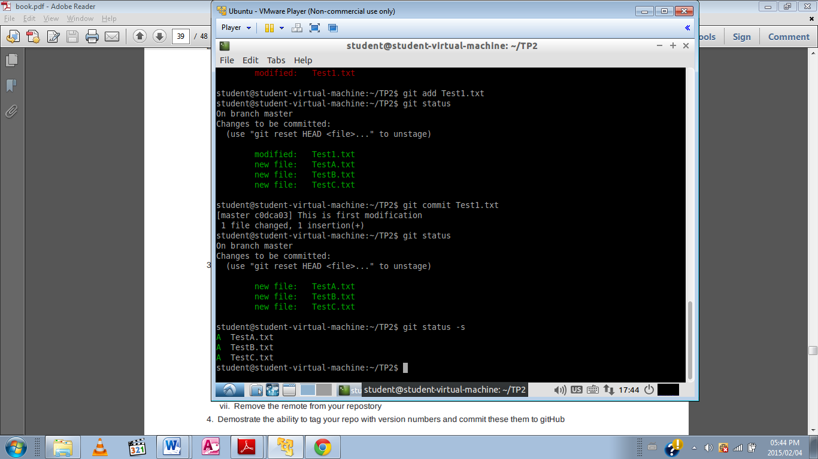

(x) and (xi) Created .gitignore file and added file to be ignored. Checked git status

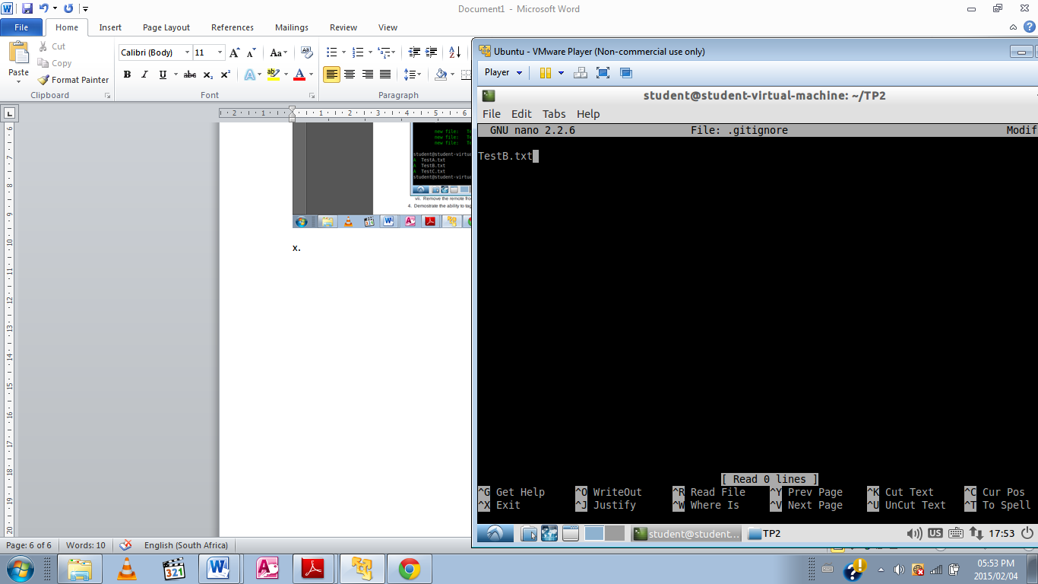

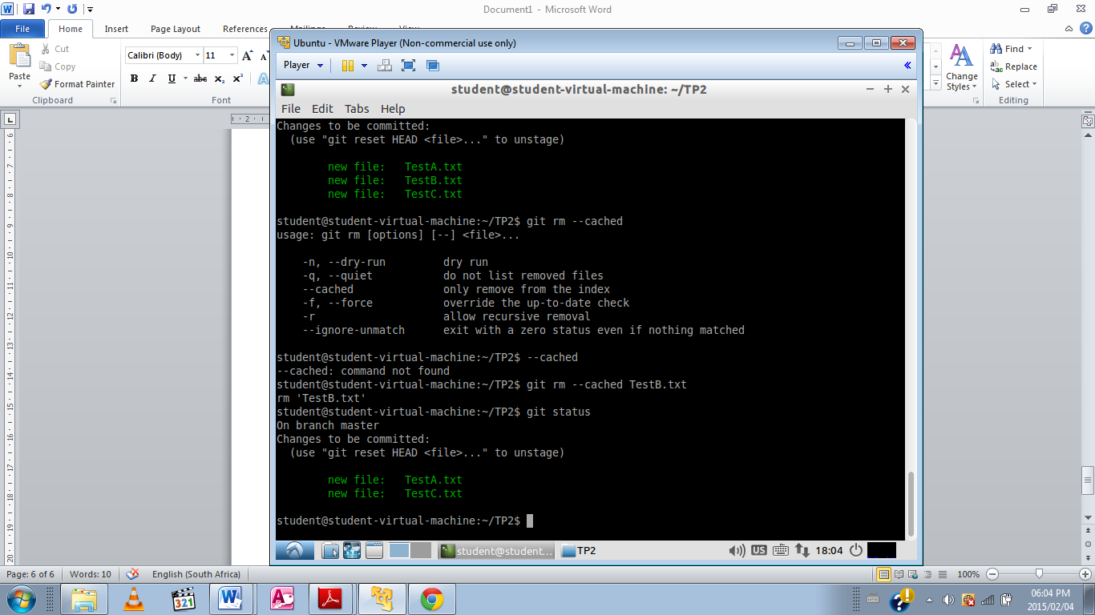

(xii) Entered command to remove TestC.txt, since the file was still being tracked –f forced remove command was added and then repository status was checked.

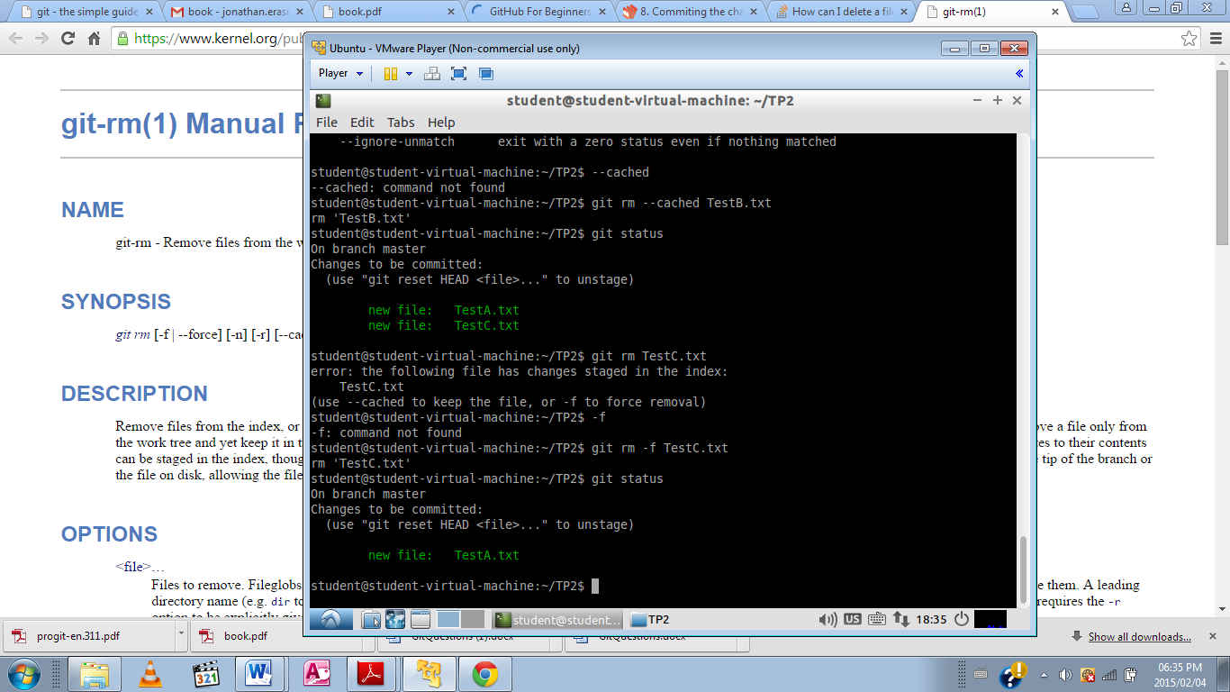

3.

(i) Created repo on GitHub and cloned it to local machine. Added command to display full remotes of repositories

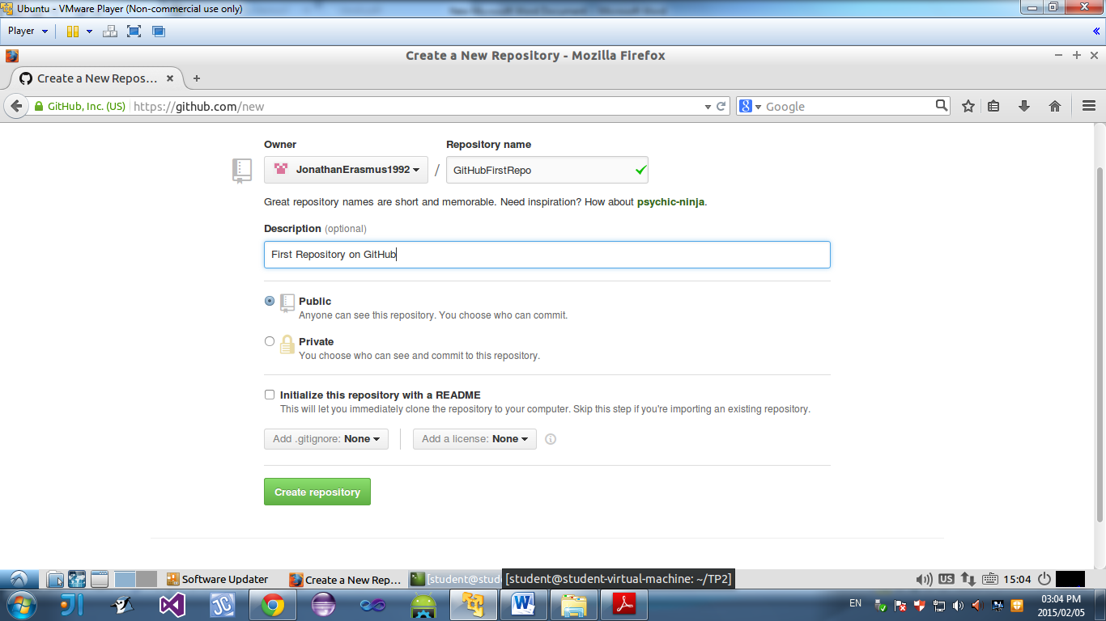

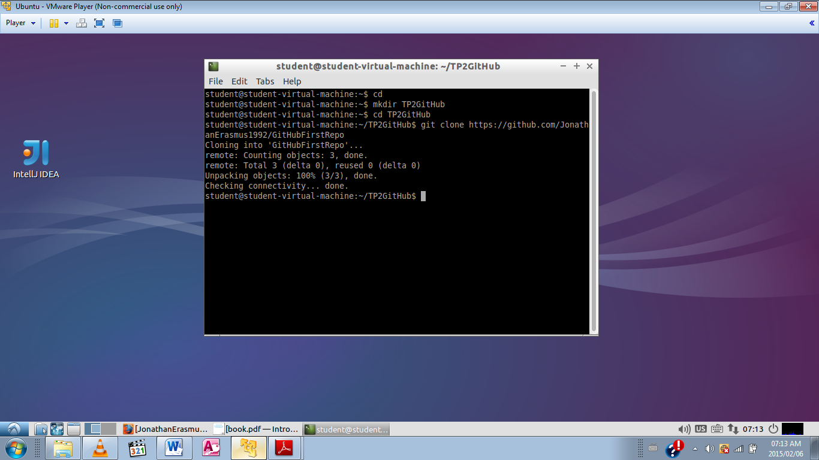

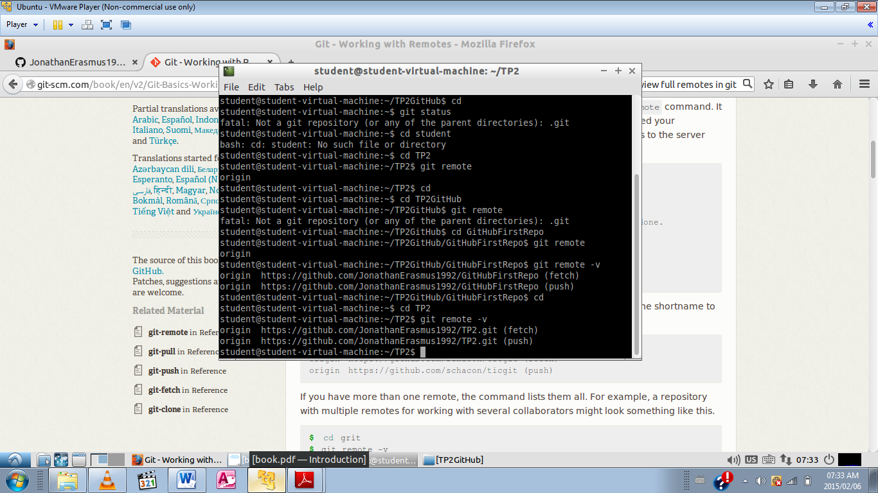

(ii) Created new file, added track and commit command then pushed to GitHub

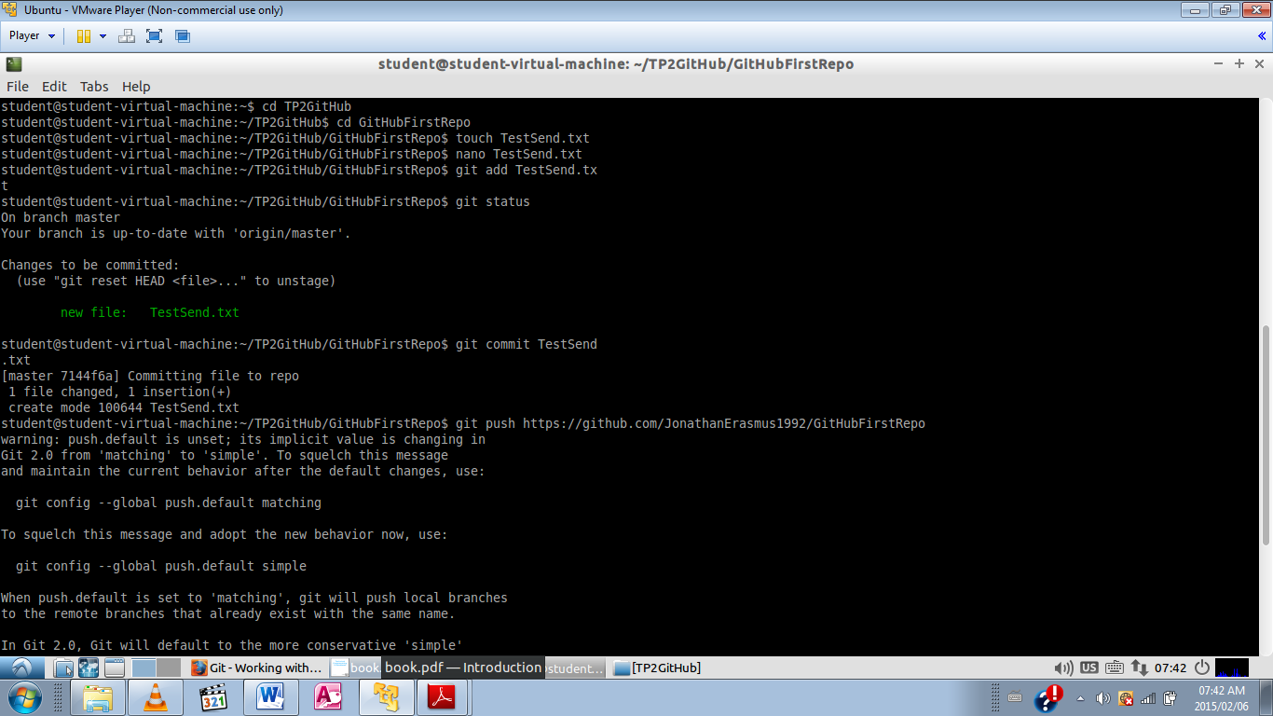

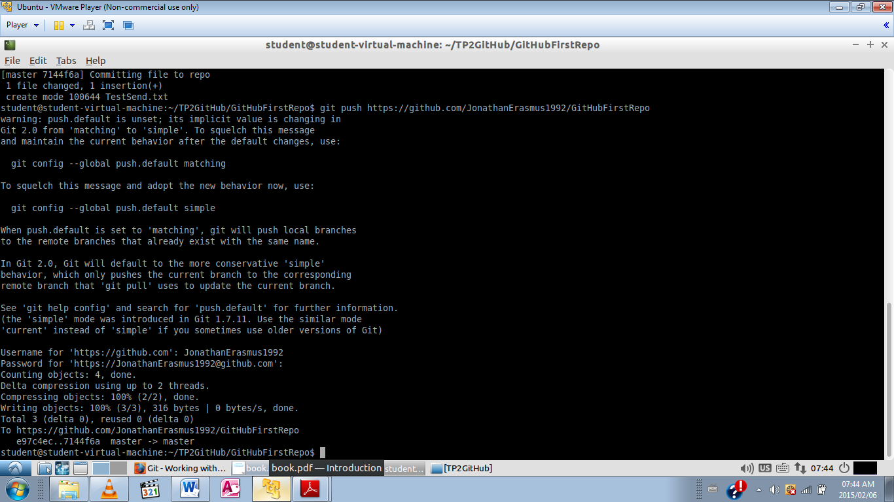

(iii) Added new Git Repo and added remote repository. Then entered command to display full remote

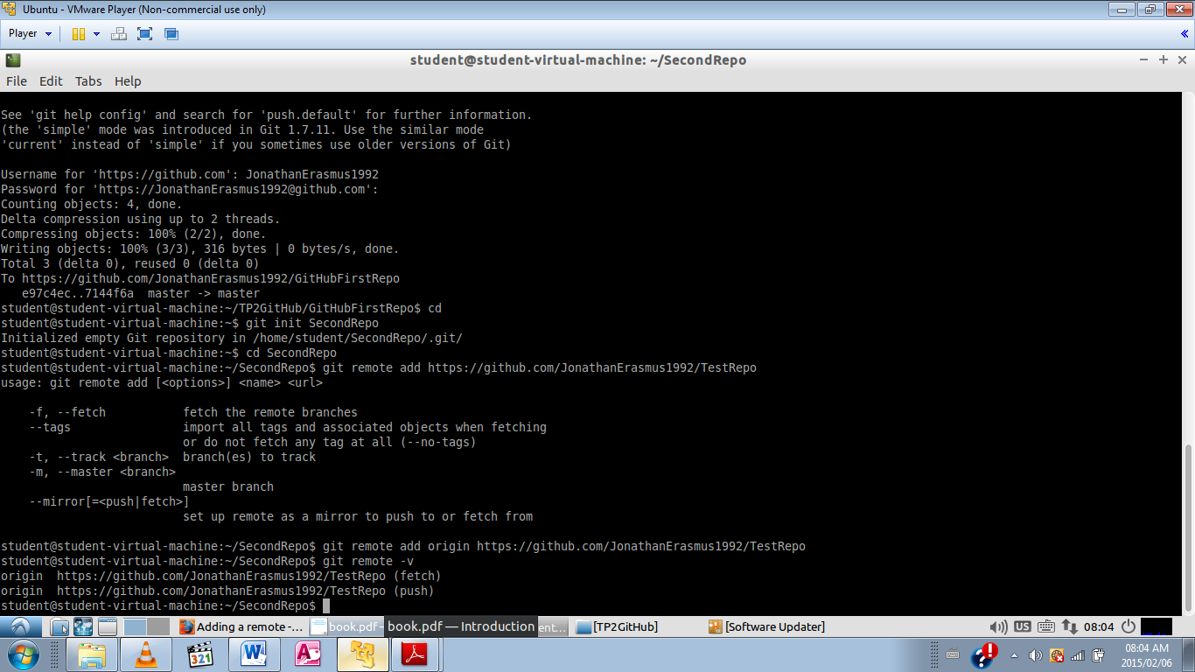

(iv) Merged remote repository into local repo

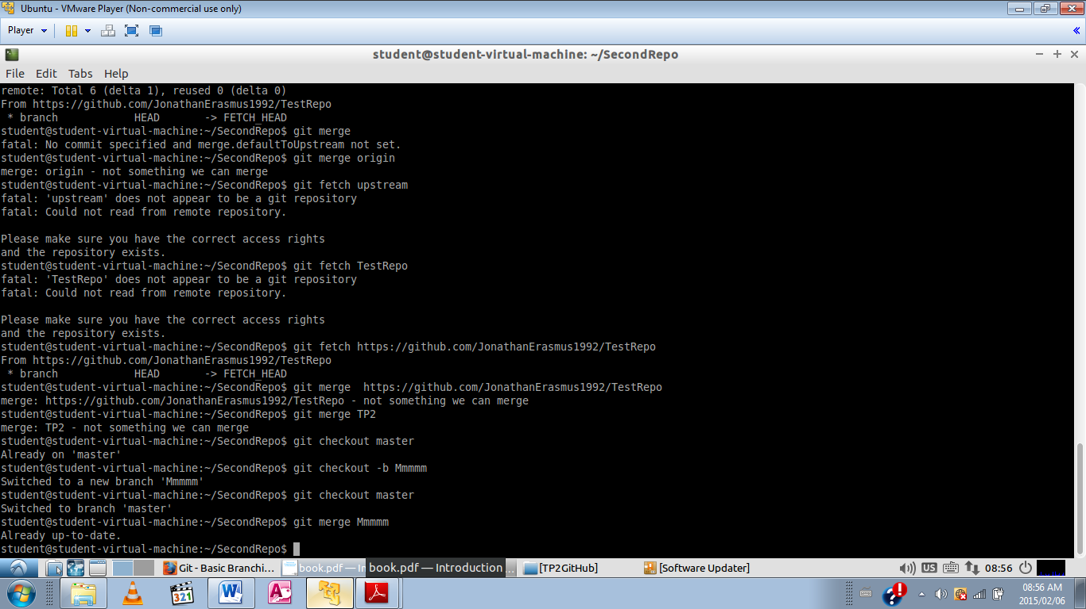

(v) and (vi) Created additional repository and used pull command to fetch and merge the repository from GitHub

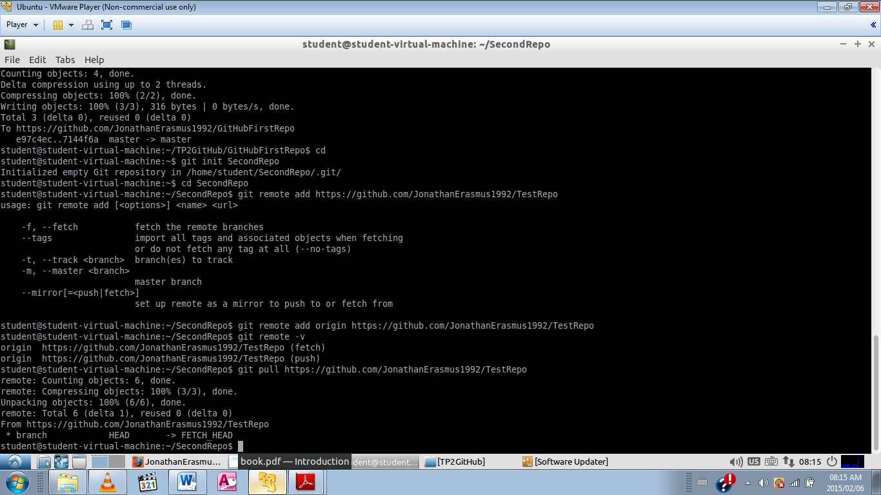

(vii) Removed remote from repository and checked to see if successfully removed

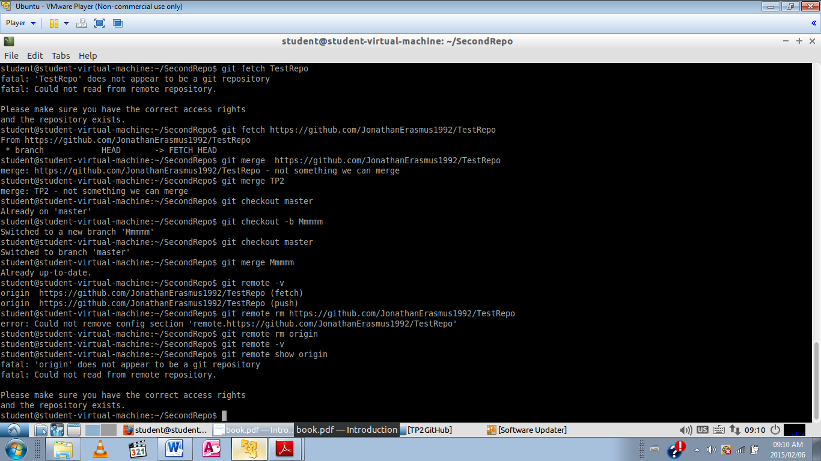

4. Added tag with version number to project version in repo

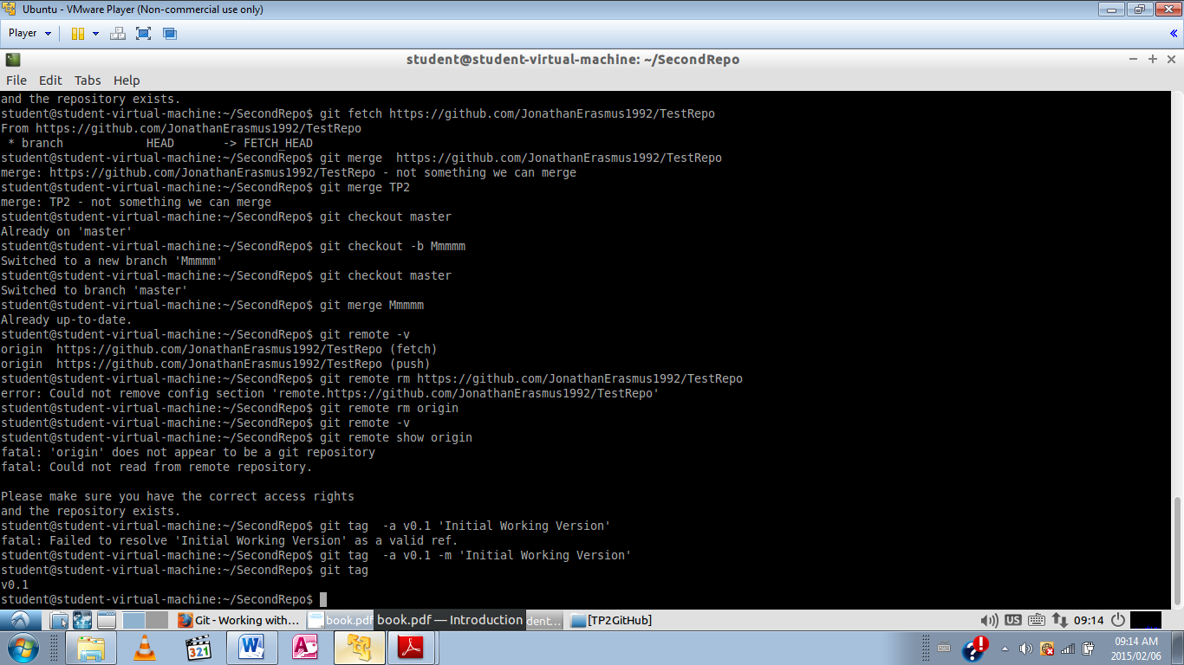

5. Created and merged branches successfully

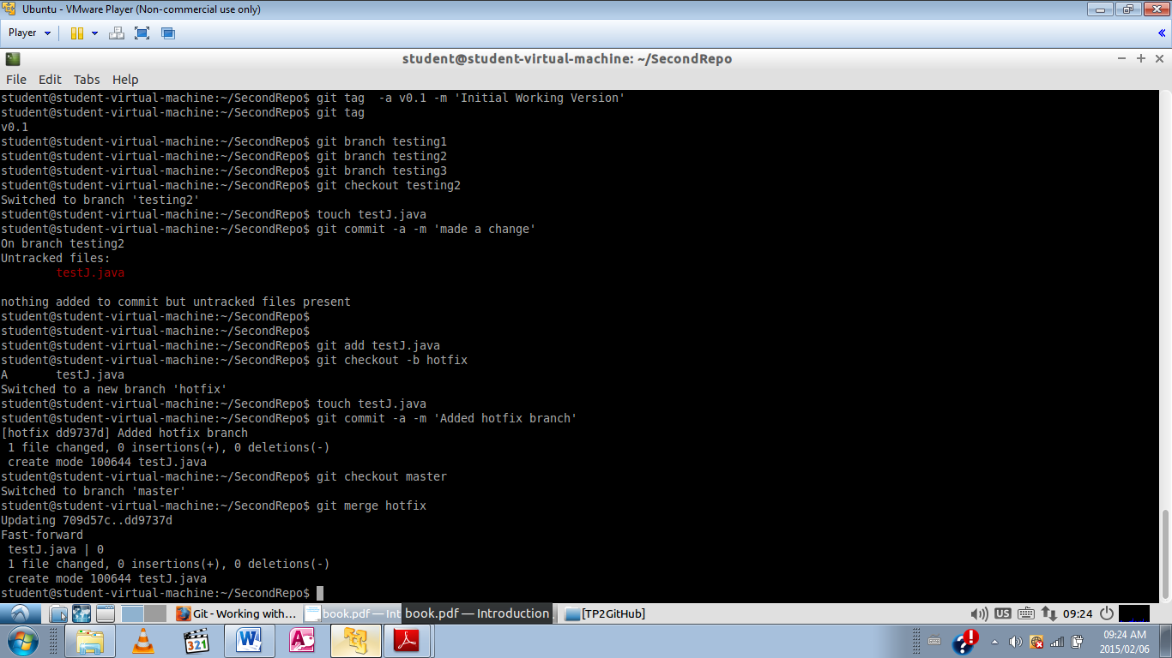

6. Created new repository on GitHub, added new branches to the repo once cloned to local machine. Then rebased branches back into master.

